AST
An Abstract Syntax Tree, or AST, is a representation of the structure of a programming language. It is a tree-like structure that is composed of nodes, each of which represents a language element like a variable, operator, or keyword. ASTs are often used to represent code written in a specific programming language, such as Python or C++.
AST abstracts away(removes) the details of syntax of language, making it easier tyo reason about the structure of code.
AST is generated by the compiler from the source code. In python, .py files are converted to AST which in turn is converted to Bytecode (.pyc file).
Working of AST:
First step is Lexical Analysis: Compiler reads the source code character by character from left to right and groups them into meaningful units called Tokens. Tokens are passed to next phase of compilation

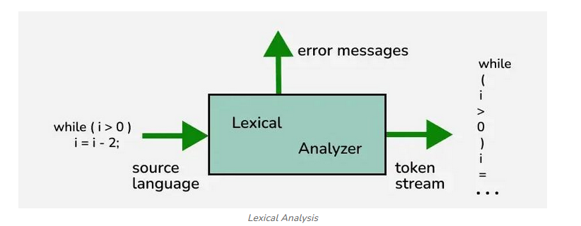

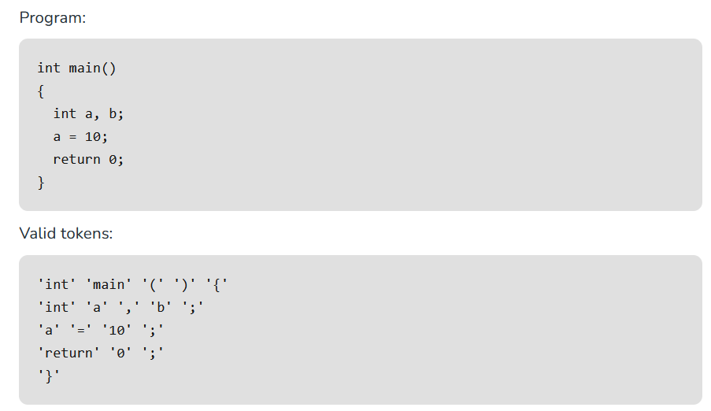
As we can see above, the source language is converted to tokens. Tokens could include keywords, identifiers, constants, operators and special symbols.
The next step is use of Syntactic Parser. Syntactic Parser is used to check the grammar of expression based on the tokens generated. Syntactic Parser parses expressions in 2 ways:
- Constituency Parsing
- Dependency Parsing
In Consistency Parsing, the sentence itself is divided into sub-phrases that belong to specific category in grammar like Nouns and Verbs. It creates relation between each of these sub-phrases. VP->VNP means VNP(Verb and Noun Phase) can be used to make VP(Verb Phase). Lets take “I saw a fox” as example. Its Constituency Parsing is:
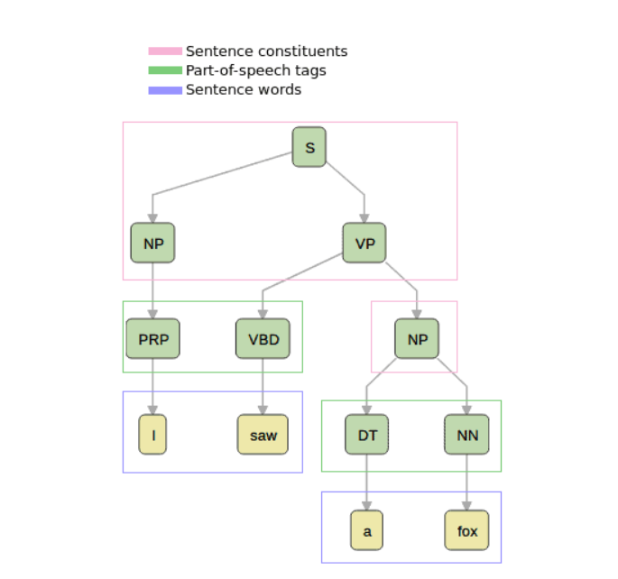
Following S->NPVP.
In Dependency Parsing, the syntax of a sentence is expressed in terms of dependencies between words.
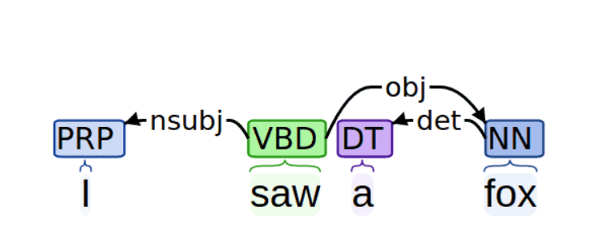
Rather that dividing the Sentence into Sub-Phases, it uses “saw” as a root word and creates relation of each word with the root.
Structure of AST:
Inside the string code, we have written the code whole ASI we want to check. We use the function ast.dump(tree) to display the structure of AST.
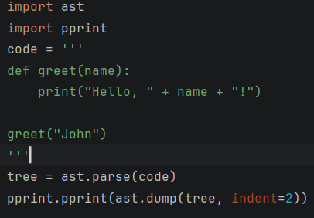
abo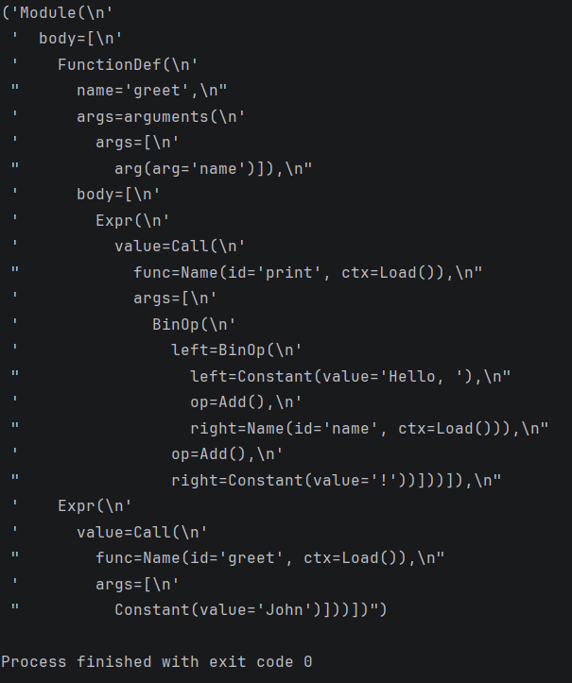
We get output as above. In this output we see that:
- The outermost node is the Module node, which represents the entire module.
- Within the Module node, there is a FunctionDef node representing the greet function definition.
- The FunctionDef node has various attributes, such as the name of the function (name) and the arguments it takes (args).
- The body of the greet function is represented by a list of nodes, in this case, containing a single “Expr” node.
- The Expr node represents an expression, and in this case, it contains a function call to print.
- The function call is represented by the “Call” node, which has the function name (“Name”) as print and the arguments it takes.
- The arguments of the print function call include a formatted string that concatenates the name argument with other strings.
The AST can be visualized in graph as below:

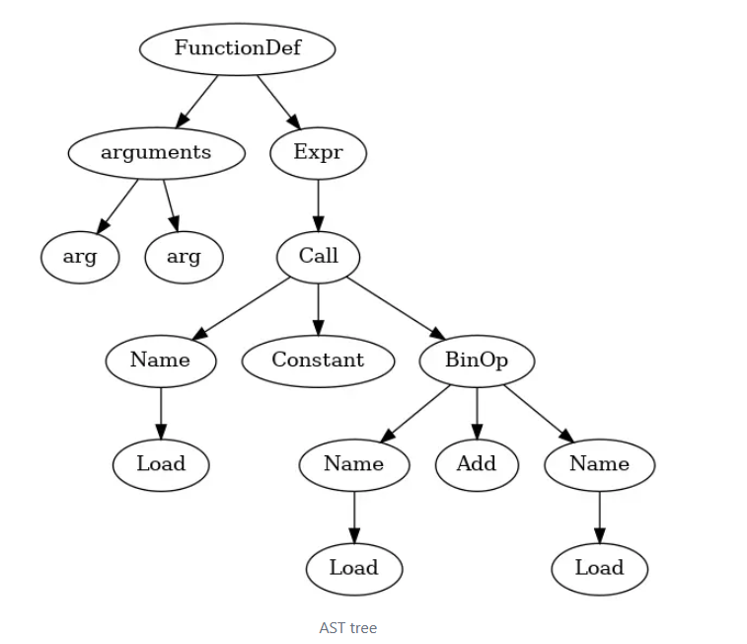
AST is used to:
- Analyze a programs code without executing it to identify potential issues.
- Transform a structure of code without changing its behavior
- As AST is language independent, it helps to translate the concept any idea of code from one language to next without having to specify the syntax itself.

